|  |
| --- |
| **Office use only** |
|  |

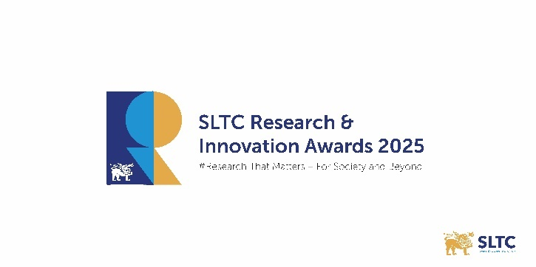

**Sri Lanka Technology Campus (SLTC)**

**Application Form for SLTC Industry Awards - 2025**

|  |  |  |
| --- | --- | --- |
| **Section A (General Information)** | | |
| **1. Entry Name** | Click here to enter text. | |
| *\*\*Please put a full name of the applicant under Entry Name* | | |
| **2. Please select the industry sector and the award(s) you wish to apply for** | | |
| **Industry Sector** | | |
| 1. Textile & Apparel | | ☐ |
| 2. Agriculture & Food Technology | | ☐ |
| 3. Energy, Electronics & Engineering | | ☐ |
| 4. Health, Wellness & Life Sciences | | ☐ |
| 5. Environment & Sustainability | | ☐ |
| 6. Materials, Polymers & Coatings | | ☐ |
| 7. ICT & Digital Innovation | | ☐ |
| 8. Creative Industries | |  |
| **Sector Based Award Category** | | |
| 1. Excellence in Inhouse R&D Award | | ☐ |
| 2. Outstanding Research Collaboration Award | | ☐ |
| 3. Outstanding Research Commercialization Award | | ☐ |
| 4. Outstanding R&D in Small and Medium Enterprises (SMEs) | | ☐ |
| **Special Awards Category** | | |
| 1. Green Impact Award for Environmental Sustainability | | ☐ |
| 2. Inclusive Growth Award for Socio-Economic Empowerment | | ☐ |

|  |  |  |  |  |
| --- | --- | --- | --- | --- |
| **Section B (Contact Information)** | | | | |
| 03. Are you filling this form on behalf of an organization? | | | | Yes/No |
| **Primary Contact** | | | | |
| 04. First Name (Primary Contact): | | Click here to enter text. | | |
| 05. Last Name (Primary Contact): | | Click here to enter text. | | |
| 06. Title (Primary Contact): | | Click here to enter text. | | |
| 07. Email Address (Primary Contact): | | Click here to enter text. | | |
| 08. Mobile Number (Primary Contact): | | Click here to enter text. | | |
| 09. LinkedIn Profile (Primary Contact) (Optional): | | Click here to enter text. | | |
| **Entry Details** | | | | |
| 1. Official Name of the R&D Project/New Product/Service/Prototype developed:   *\*\*Please enter the official name of your project or product EXACTLY as it should appear in all SLTC Research & Innovation Awards website, newsletters, press announcements, trophies & certificates, etc.*  Click here to enter text. | | | | |
| 1. Nominee Company Name:   *\*\*Please enter the official name of the company to which the research project/product/technology/ intellectual property belongs to.*  Click here to enter text. | | | | |
| 1. Company Website URL: | Click here to enter text. | | | |
| 1. Link to Product Website (optional): | | | Click here to enter text. | |

|  |  |  |  |
| --- | --- | --- | --- |
| **Section C (Company Demographics)** | | | |
| **30. Please select the industry category to which your company belongs to** | | | |
| Small & Medium Enterprise (Annual revenue less than LKR 500 million) | ☐ | | |
| Large Scale Enterprise (Annual revenue more than LKR 500 million) | ☐ | | |
| 1. How many people does your company employ? | | Click here to enter text. | |
| 1. What industry is your company in? | Click here to enter text. | | |
| 1. Where is your company headquartered? | Click here to enter text. | | |
| 1. **Please select your organization type** | | | |
| Registered Private Company / Business Enterprise | | ☐ | |
| Non-Governmental Organization (Local / International) | | ☐ | |
| Multinational Corporation (MNC) | |  | |
| Industry Association / Professional Body | |  | |
| Other (Please Specify) : Click here to enter text. | | ☐ | |
| 1. Please provide your company registration number | | | Click here to enter text. |
| 1. Please state the date of establishment of your company | | | Click here to enter text. |

|  |  |  |
| --- | --- | --- |
| **Section C (Information About the Research Project)** | | |
| 1. Title of the Research | Click here to enter text. | |
| 1. Start Date of the Research | Click here to enter text. | |
| 1. End Date of the Research (if applicable) | Click here to enter text. | |
| 1. Research Team (List all names and affiliations) | | Click here to enter text. |
|  | | |
| **Summary of the Research Project** | | |
| 1. **Project Overview:** *What problem or opportunity does your project address, and why is it important for your industry? What are the main goals of your project? (Maximum 100 words)*   Click here to enter text. | | |
| 1. **Innovation & Originality:** *What is new or unique about your project or approach? Does it involve a new product, process, service, or idea? (Maximum 100 words)*   Click here to enter text. | | |
| 1. **Potential Impact**   *Describe the expected benefits of your project for your organization, sector, or industry if successfully implemented. (Maximum 100 words)*  Click here to enter text. | | |
| 1. **Research Approach**   *What methods or approaches did you use for your project? (Maximum 100 words)*  Click here to enter text. | | |
| 1. **Outputs & Feasibility**   *What are the main results or outputs of your project? How can they be applied in your industry? (Maximum 100)*  Click here to enter text. | | |
| 1. **Competitive Advantage & Scalability**   *How does your project stand out from existing solutions? What is its potential to grow, scale, or expand in your sector? (Maximum 100 words)*  Click here to enter text. | | |
| 1. **Intellectual Property & Supporting Documents**   *List any patents, trademarks, copyrights, trade secrets, or other IP associated with your project. Attach any relevant supporting documents (reports, prototypes, data, photos, videos, etc.).*  Click here to enter text. | | |
| 1. **For commercialized projects only:**   *Briefly describe your project’s commercialization stage, market adoption, intellectual property ownership, and its practical impact or potential for future growth. (Maximum 100 words)*  Click here to enter text. | | |
| 1. **For collaborative research projects only:**   *Please clearly state all collaborating entities involved in the project, including the roles and contributions of each partner.*  Click here to enter text. | | |

.

* and projects, state whether SLTC is a direct beneficiary.

**Declaration**

I hereby declare that the information and documents provided in this application are true, complete, and accurate to the best of my knowledge. I confirm that this project is my organization’s original work and that all contributors have been appropriately acknowledged.

I understand that any false information or misrepresentation may result in disqualification from the SLTC Research & Innovation Awards 2025. I also grant permission for SLTC to use the submitted information for evaluation, promotion, and publicity purposes related to the Awards.

By signing below, I acknowledge and agree to the terms of this declaration.

|  |  |
| --- | --- |
| **Name:** | Click here to enter text. |
| **Designation:** | Click here to enter text. |
| **Contact Email** | Click here to enter text. |
| **Date:** | Click here to enter text. |
| **E-Signature:** | Click here to enter text. |

-END-